**The** [***Focus on Communities***](https://photovoice.org/focusoncommunities/) **Photovoice Project**

**Project Description:**

‘Focus on Communities’ was a project conducted in London, England which explored the perspectives of individuals who use the services provided by a number of community centers. The participants ranged in age from 4 to 80+.

**The Issue:**

Many residents in these areas have few chances to be involved in the arts, and are socially isolated due to poverty and inequality. ‘Focus on Communities’ provided a way for engagement which aimed to improve social spaces in the community. By working in close partnership with community centers, it offered new activities to its members, building skills and confidence, and creating a rich archive of images and stories and sharing perspectives on what community means to those who live there.

**Delivery:**

Residents attended short workshops to learn about photovoice and photography, and were encouraged to use photovoice to share their stories and perspectives about social spaces and the community. Nearly 50 residents participated. A series of exhibition events were held where participants were able to see their work exhibited. These events were also attended by local councillors, who were able to share the publication with others, further spreading the stories that the participants had shared.

**Photovoice Images**

1. Write a short caption below each image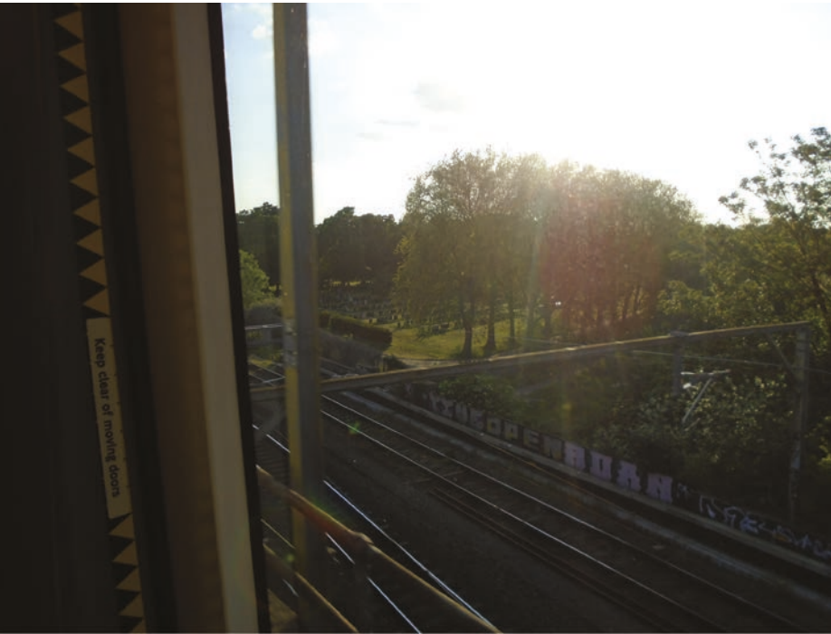
2. Try to describe the meaning of the photo aloud with your group

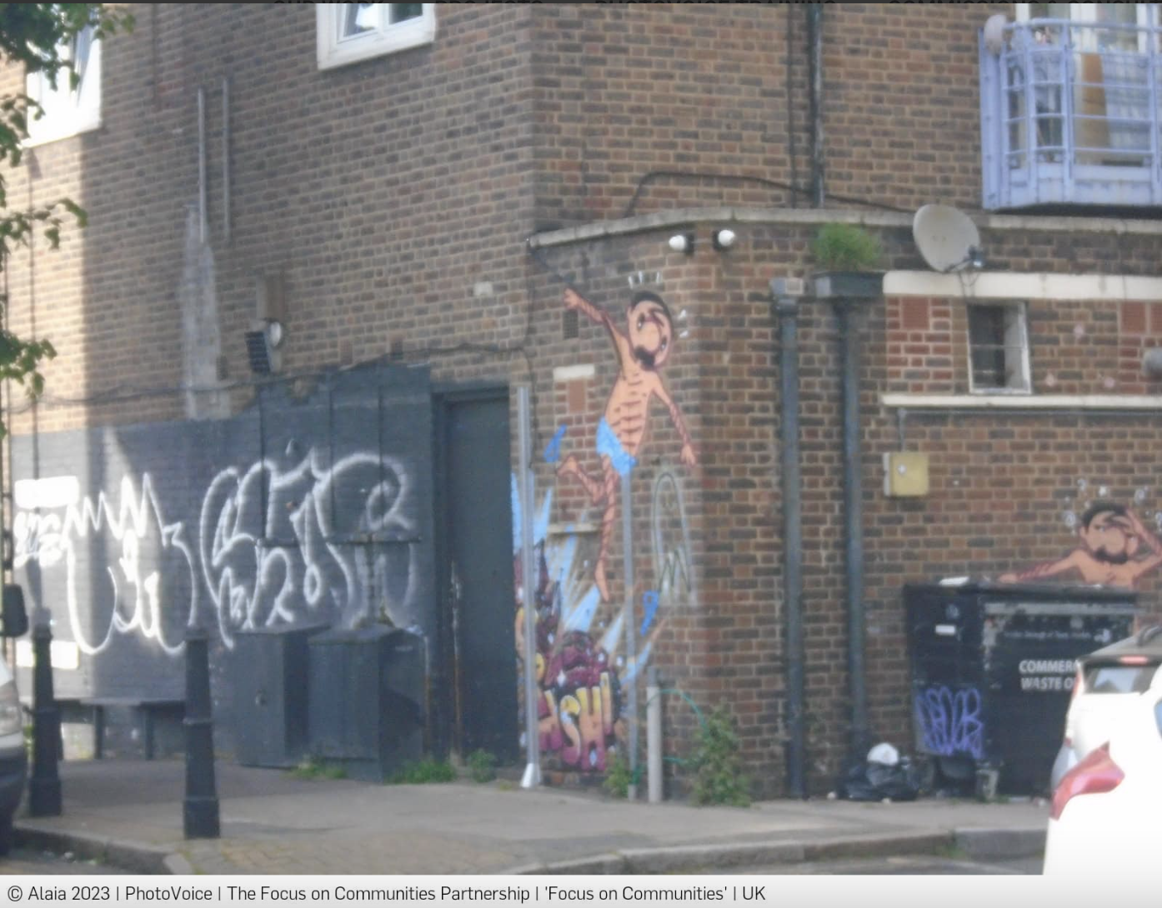

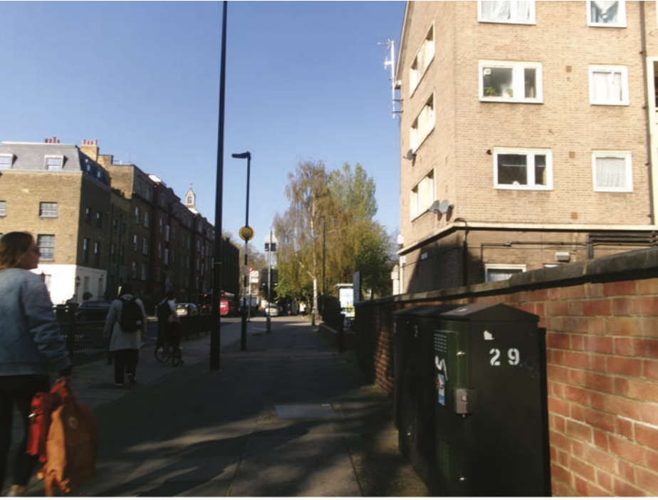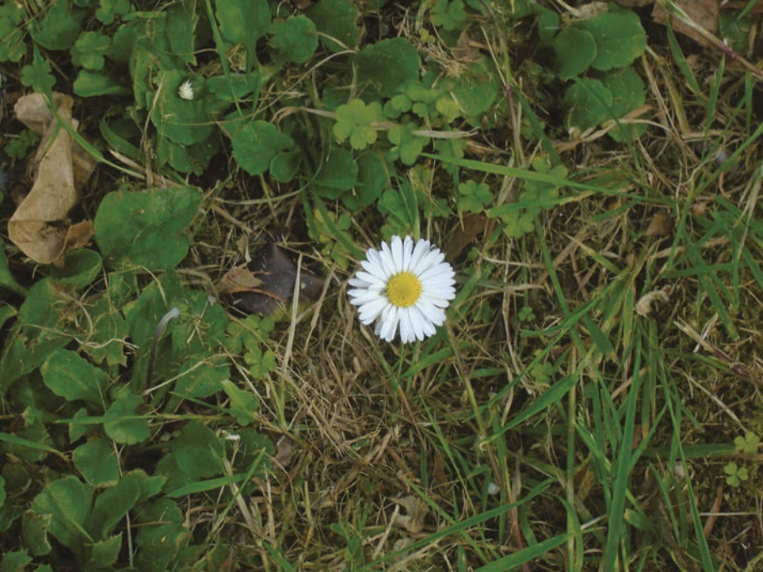

**Brainstorm for our project**

What kind of photos would you take?

Where would you take these photos?

When could you take these photos?

Tips: The SHOWED method provides the following guidelines for eliciting discussion about the photographs:

* What do you *S*ee in the picture?
* What is *H*appening in the picture?
* How is it related to *O*ur life?
* *W*hy does this condition exist?
* How can we be *E*mpowered by understanding this issue?
* What can we *D*o to address it?

Photo prompt examples:

* Take a photo of a place that feels peaceful or green. Why does it matter to you or your community?
* Capture a space that you think needs more trees, plants, or green areas. What’s missing?
* Show an area where nature and people interact — is it working well or not?
* Find a place that gets really hot in the summer. What could help cool it down?
* Take a picture of a green space that isn’t being used. Why do you think that is? What could change?
* Take a picture of something beautiful that already exists — a tree, garden, mural, etc. How can we protect or expand it?
* Take a photo that shows something about housing in your neighborhood — what do you notice?
* Capture a sign of poor housing conditions. How does this affect people’s lives?
* Show something that makes a house feel like a home. Why is it important?
* Photograph a place where the condition of the housing and the environment overlap (e.g., flooding, heat, pests).
* Find a building or home that needs care. What would you fix if you could?
* Take a photo of something that shows pride in your community.

Below are the ACTUAL captions of the photos in order of the photos presented. Before sharing the actual captions, we can ask youth to make a short title, and try to describe the meaning of the photo.

* Graffiti: When I open my door, I see graffiti. It’s been there for many years and it’s so beautiful. The colours of expression. It shows how we are all different and how it doesn’t matter how we look, but who we are.
* Big fat death: This picture represents deforestation and animal cruelty as the tracks and bulldozers have run them and the trees down, destroying the animals habitats and lives!
* Daisy: Flowers play a huge part in the community. When I think of community, I think of the people with smiles on their faces. A flower is something simple but it can do a lot to someone’s day. I believe that a flower is all it takes for a happy community and one single thing can change a lot.
* No title: My area has trees which makes it nicer to look at because it’s green.